Desk Number ________

Student Number _______________________

Student Name _______________________

**School of Science and Engineering**

**FINAL EXAMINATION (B)**

Semester 2, May, 2021

**CSC1001 Introduction to Computer Science**

Examination Duration: 120 minutes

Reading Time: 10 minutes

This examination has __3__ questions.

**Exam Conditions:**

This is a FORMAL Examination

This is a RESTRICTED OPEN BOOK Exam. Maximum of one (1) sheet of handwritten notes double sided are permitted

**Materials Permitted In The Exam Venue:**

Maximum of one (1) sheet of handwritten notes double sided are permitted. **NO OTHER MATERIALS PERMITTED**

Any calculators without the functionalities of programming and file storage are permitted.

**Materials To Be Supplied To Students:**

1 × 9 Page Answer Booklet

Question 1. (10 × 3% = 30%)

Pick the correct option in each of the following sub-questions. Note that only ONE option is correct.

* 1. Binary number 1101111.111 and hexadecimal number 5FC.3 equal to decimal numbers: A

1. 111.875 and 1532.1875
2. 110.85 and 1532.1875
3. 111.111 and 1712.1875
4. 110.85 and 1712.375
   1. Concerning Python language, which of the following statements is incorrect? C
5. Python uses an interpreter to translate source codes into machine codes.
6. In Python, reserved words cannot be used as variable names.
7. In Python, a variable has a fixed location in the memory.
8. true and false are not reserved words in Python.
   1. Concerning the following program, which of the following statements is incorrect? C

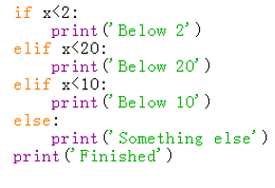

1. print(‘Below 2’) will be executed when $x=1$.
2. print(‘Below 20’) will be executed when $x=10$.
3. print(‘Below 10’) will be executed when $x=8$.
4. print(‘Something else’) will be executed when $x=20$.
   1. Concerning the object in Python, which of the following statements is incorrect? D
5. Every object in Python has a unique ID.
6. The type of an object is determined automatically by Python interpreter according to its value.
7. Every variable is essentially a reference to an object.
8. The ID of an object may be changed during the execution of the program.
   1. Concerning stack and queue, which of the following statement is correct? A
9. A stack can be accessed based on the “last in first out” principle and the time complexity of inserting an element into a stack is constant.
10. More than one elements of a stack can be accessed simultaneously if necessary.
11. Elements can be inserted at any time in a queue, but only the element that has been in the queue the shortest can be next removed.
12. The time complexity of removing an element from a stack or a queue is linear.
    1. Concerning the following program, which of the following statements is incorrect? C

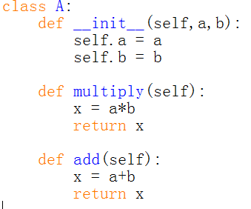

1. Class A() contains two newly defined data fields.
2. The scope of self is throughout the whole body of class A().
3. Method add() will return the sum of two data fields a and b.
4. Variable x defined in multiply() and add() are two different local variables.
   1. Concerning the following two programs, which of the following statements is incorrect? B

|  |  |
| --- | --- |
|  |  |

1. When executing the first program, an error will be triggered.
2. When executing the second program, an error will be triggered.
3. The first class A() will inherit the initializer from its parent class.
4. The a.setRadius(3) statement of the second program aims to set the radius of a to 3.
   1. Concerning private members of a class, which of the following statements is incorrect? C
5. In Python, the names of private data fields and private methods start with 2 underscores and do not end with 2 underscores.
6. Private data fields can be accessed within a class.
7. Private methods can be directly accessed outside the class definition.
8. Private data fields are defined to prevent potential data corruption.
   1. Concerning the following program, which of the following statements is incorrect? A

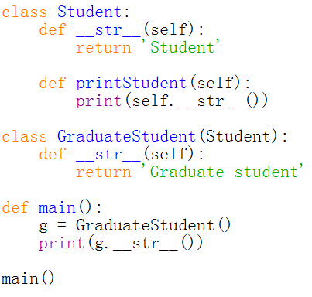

1. The output of this program is ‘Student’.
2. Class GraduateStudent() has inherited the method printStudent().
3. Method __str__() has been overridden in class GraduateStudent().
4. In class GraduateStudent(), method printStudent() will be inherited from class Student().
   1. Concerning the binary search algorithm, which of the following statement is correct? A
5. This algorithm is able to find out whether a target element exists in a given sequence of elements.
6. Binary search algorithm can be applied on an unsorted sequence.
7. The time complexity of binary search is O(n).
8. Binary search is usually equally efficient compared with sequential search.

Question 2. (10 × 4% = 40%)

Pick the correct option/s in each of the following sub-questions. Note that there may be MULTIPLE correct options for each sub-question.

* 1. Concerning recursion, which of the following statement/s is/are correct? BCD

1. When a function makes two or more recursive calls, this function does not belong to multiple recursion.
2. A recursive algorithm should have one or more base cases which is or are non- recursive
3. To write a recursion program, we usually need to define the problem in a recursive way first.
4. The base case in recursive algorithm can return nothing
   1. Concerning the following program, which of the following statement/s is/are correct? A

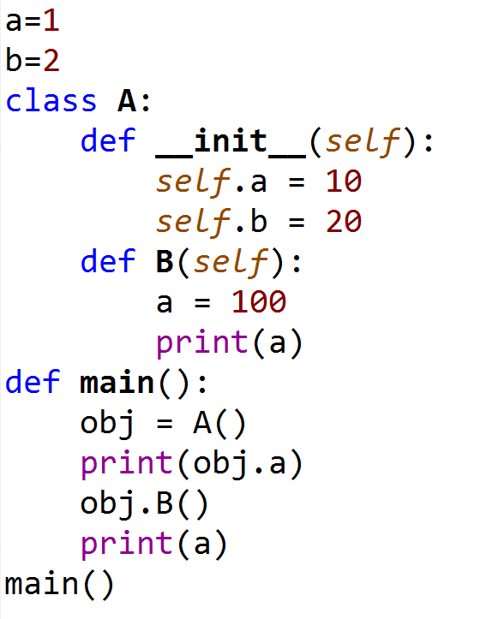

1. In this program, three different variables a have been defined.
2. Data field a of class A() can only be accessed within the class definition.
3. The value of global variable a will initially be set as 1, and then changed to 100.
4. The output of this program is

10

100

100

* 1. Given the program, which of the following statement/s is/are correct? AC

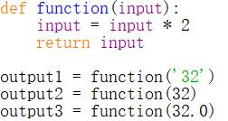

1. The data types of output1, output2, output3 are: str, int, float
2. output1 is exactly: 64
3. output2 is exactly: 64
4. output3 is exactly: 64
   1. Concerning algorithm analysis, which of the following statement/s is/are correct? AB
5. The big-Oh notation allows us to say that a function f(n) is always less than or equal to another function g(n) up to a constant factor when n is large enough.
6. The big-Oh notation is usually used to characterize the running time of an algorithm in the asymptotic sense.
7. Function $5n^{4}+6n^{3}+2n^{2}+2^{n}+2n$ is O($n^{4}$).
8. When we analyse an algorithm, we are usually interested at its average performance regardless of the input size.
   1. Assume that the five numbers 1, 2, 3, 4, and 5 are pushed onto the stack, which of the following statement/s is/are correct?: CD
9. If the numbers are pushed in the order of 1-2-3-4-5, then the first number popped will be 1.
10. In Python, these five numbers are essentially saved in a list.
11. The stack can be implemented based on a dictionary.
12. The time complexity of popping out all elements in the stack is O(n).
    1. Concerning the binary search algorithm, which of the following statement/s is/are correct? ACD
13. The purpose of this algorithm is to find out whether a target element exists in a given sequence of elements.
14. Binary search algorithm can be applied on an unsorted sequence.
15. The time complexity of binary search is O(log n).
16. Binary search is usually more efficient than sequential search.
    1. Concerning stack, which of the following statement/s is/are correct? AD
17. A stack can be accessed based on the “last in first out” principle.
18. More than one elements of a stack can be accessed simultaneously if necessary.
19. The time complexity of Inserting an element into a stack is linear.
20. The time complexity of removing an element from a stack is constant.
    1. Concerning queue, which of the following statement/s is/are correct? A
21. Data are saved sequentially in a queue.
22. Data can only be removed from the tail of a queue.
23. Data can only be inserted at the head of a queue.
24. A queue can only be implemented based on a list.
    1. Concerning linked list, which of the following statement/s is/are correct? ABD
25. We can identify the tail of a singly linked list as the node having None as its next reference.
26. The time complexity of inserting a node at the tail of a singly linked list is constant.
27. The time complexity of removing a node at the tail of a singly linked list is constant.
28. Every node in a doubly linked list contains at least two references.
    1. Concerning a binary tree, which of the following statement/s is/are correct? ABC
29. In a binary tree, data are saved hierarchically.
30. In a non-empty binary tree, there is only one node which has no parent.
31. Every node on a binary tree contains at least three references.
32. In a binary tree, every node has zero or two child nodes.

Question 3. (10% + 8% + 12% = 30%)

Answer the following questions.

* 1. Concerning the following program

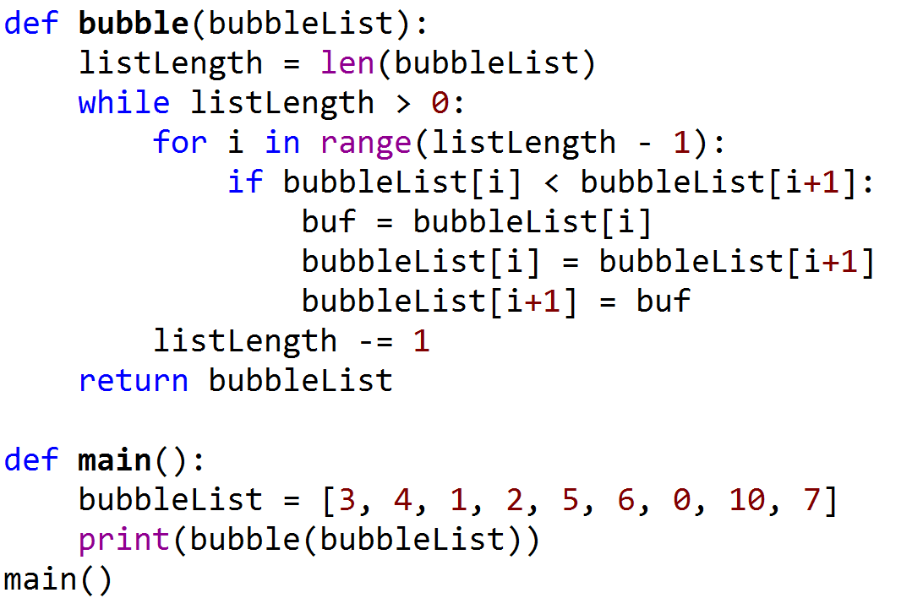

Answer the following questions:

1. What are the outputs of this program?
2. Which sorting algorithm is applied in this program?
3. What is the time complexity of this sorting algorithm?

**Answer:**

1. [10,7,6,5,4,3,2,1,0] 3 points
2. bubble sort 3 points
3. O(n2) 4 points
   1. Concerning the following program

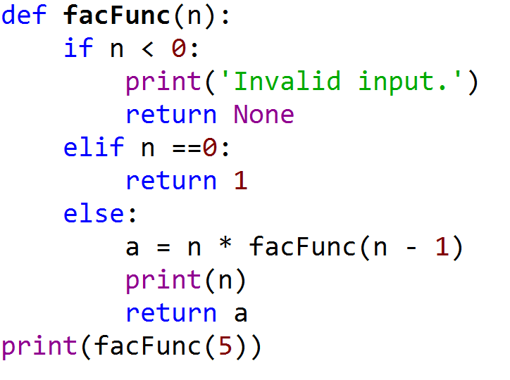

Answer the following questions:

1. How many times function facFunc() will be called in total ?
2. What are the outputs of this program?

**Answer:**

1) 6 3 points

2) 5 points

1

2

3

4

5

120

* 1. Concerning the following program, and assume that input t will be a reference pointing to the root of a binary tree.

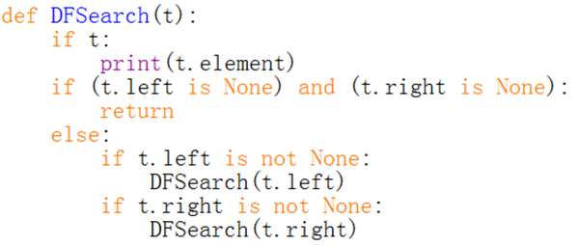

Answer the following questions:

1. Which algorithm is implemented in this function?
2. What is the time complexity of this algorithm?
3. Is this function a linear recursive or multiple recursive function?
4. If input t is referencing to the root of the following tree, what would be the outputs of this function?

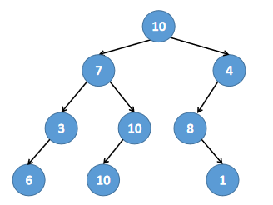

**Answer:**

1) Depth First Search 3 points

2) O(n) 3 points

3) multiple recursive function 3 points

4) 10 3 points

7

3

6

10

10

4

8

1

**END OF EXAMINATION**